2.01 Compare GIF and JPG

Image 1 was downloaded from the Internet. Its original format was JPG. It was resaved in a GIF format. Discuss and record what happened to the file size and the quality of the photograph when it was saved it as a GIF.

Image #1  Swimmer1  .JPG  File Size  1.6 Mbytes | 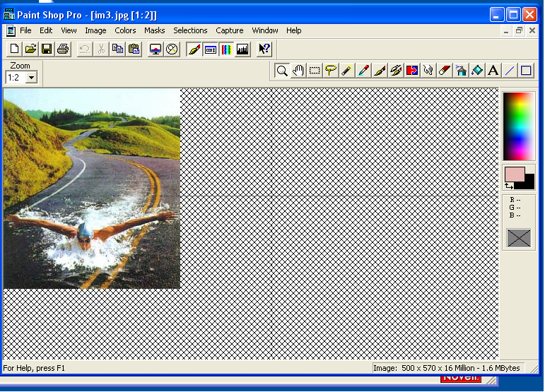
Image #2  .GIF  File Size  556 Kbytes | 