NAME: CLASS: DATE:

Let’s Get Fooducated!

Product: Ingredient List: Nutrition Facts:

.5g

1. What do you think is used to sweeten this cereal?

2. Underline all the sweeteners listed in the Ingredient List. How many did you find?

3. How many grams of sugar per serving?

4. Approximately how many teaspoons of sugar are in a serving of this cereal?
(HINT: there are 4 grams of sugar per teaspoon)

5. Are there any nuts in Honey NUT Cheerios?

6. What cereal do you like to eat?

7. Fooducate recommends a cereal with 6 or less grams of sugar per serving.
Does this cereal have more sugar or less?

8. What nutrition grade should this product get? (examples: A, B+, C-) Write the grade in the
Nutrition Grade circle above.
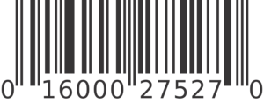

Scan this barcode with the
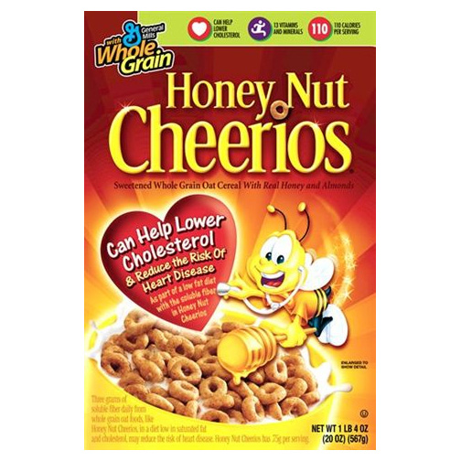

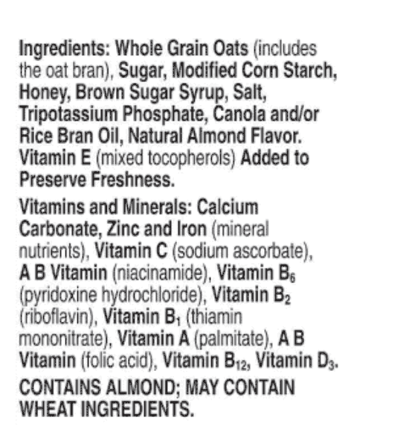

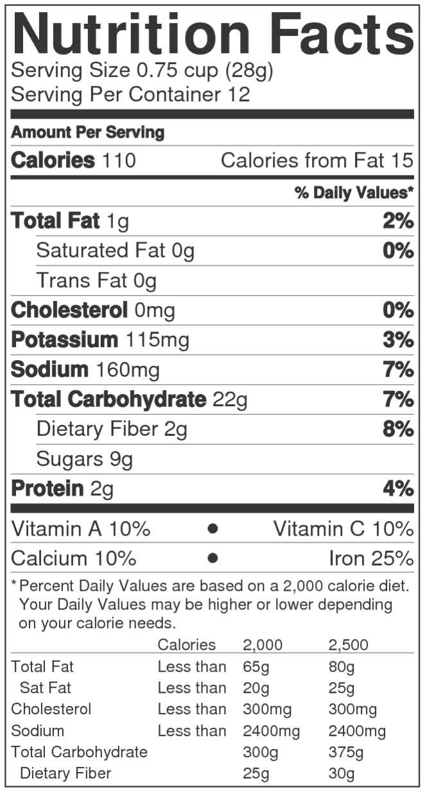

Fooducate app to learn more

www.fooducate.com

NAME: CLASS: DATE:

Let’s Get Fooducated!

Product: Ingredient List: Nutrition Facts:

TOMATO CONCENTRATE FROM RED RIPE TOMATOES, DISTILLED VINEGAR, HIGH FRUCTOSE CORN SYRUP, CORN SYRUP, SALT, SPICE, ONION POWDER, NATURAL FLAVORING.
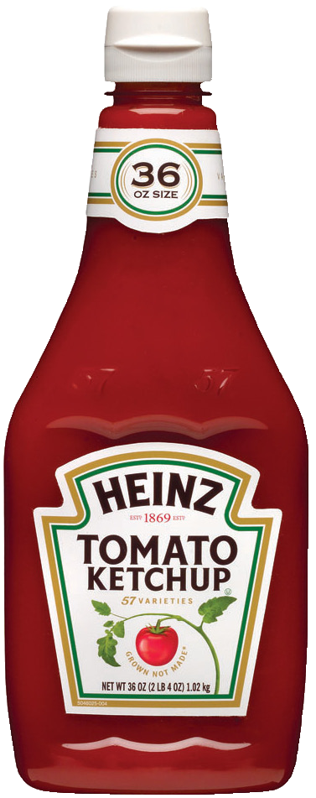

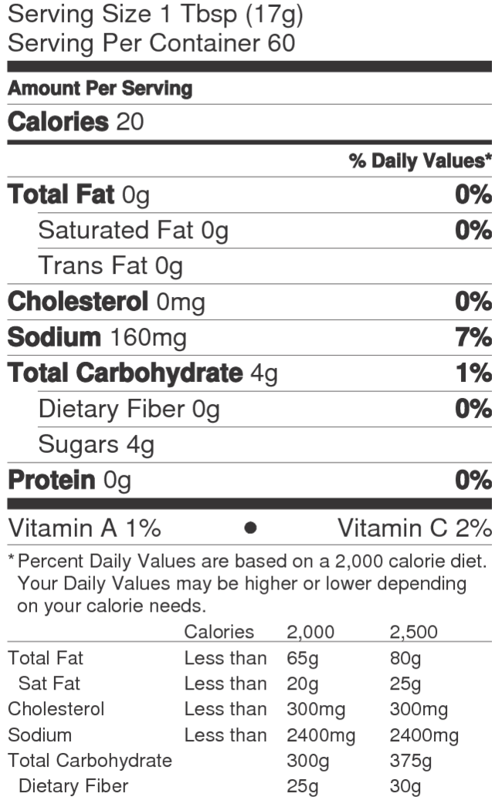

1. Read the ingredient list. What sweeteners are used here?

2. What is a serving size for ketchup? Do you use more than that or less?

3. How many grams of sugar are in a single serving of ketchup?

4. How many teaspoons of sugar are in a single serving of ketchup?
(HINT: there are 4 grams of sugar per teaspoon)

5. What other condiments could you use instead of ketchup?

6. What nutrition grade should this product get? (examples: A, B+, C-) Write the grade in the
Nutrition Grade circle above.

Scan this barcode with the
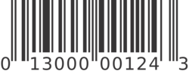

Fooducate app to learn more

www.fooducate.com

NAME: CLASS: DATE:

Let’s Get Fooducated!

Product: Ingredient List:

Carbonated Water, High Fructose Corn Syrup, Caramel Color, Phosphoric Acid, Natural Flavors, Caffeine
Nutrition Facts:

(12 fl oz)
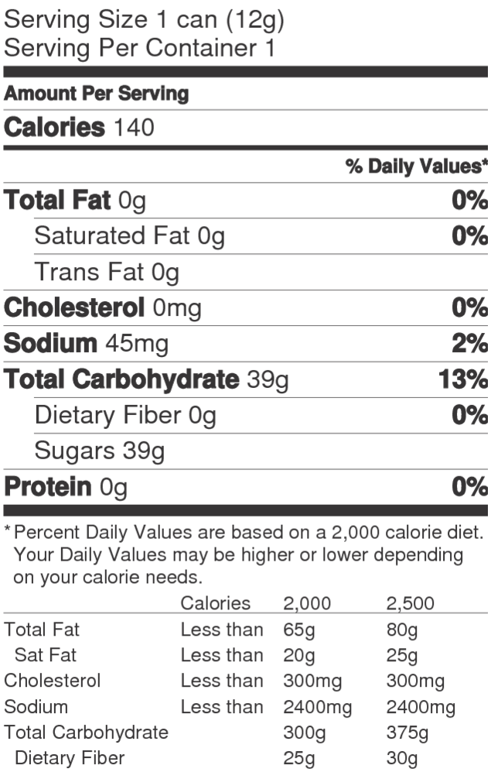

1. How many grams of sugar are in this can?

2. Approximately how many teaspoons of sugar are in this sodal?
(HINT: there are 4 grams of sugar per teaspoon)

3. Have you ever tried drinking a glass of water with the same amount of sugar added?

4. How many calories are in a can?

5. How many of the calories are from sugars?
(HINT: each sugar is 4 calories)

6. What would be a better alternative to a soft drink?

7. What nutrition grade should this product get? (examples: A, B+, C-) Write the grade in the
Nutrition Grade circle above.

Scan this barcode with the
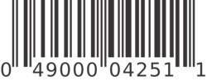

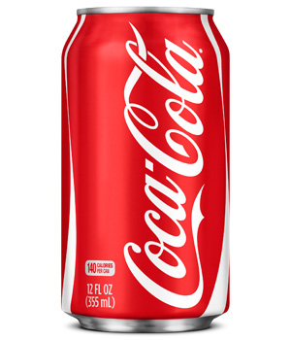

Fooducate app to learn more

www.fooducate.com

NAME: CLASS: DATE:

Let’s Get Fooducated!

Product: Ingredient List: Nutrition Facts:

Enriched Flour (Wheat Flour, Niacina- mide, Reduced Iron, Thiamin Mononi- trate [Vitamin B1], Riboflavin [Vitamin B2], Folic Acid), Corn Syrup, High Fruc- tose Corn Syrup, Dextrose, Vegetable Oil (Soybean, Cottonseed and Hydro- genated Cottonseed Oil (Less than 0.5 g Trans Fat per Serving) with TBHQ and
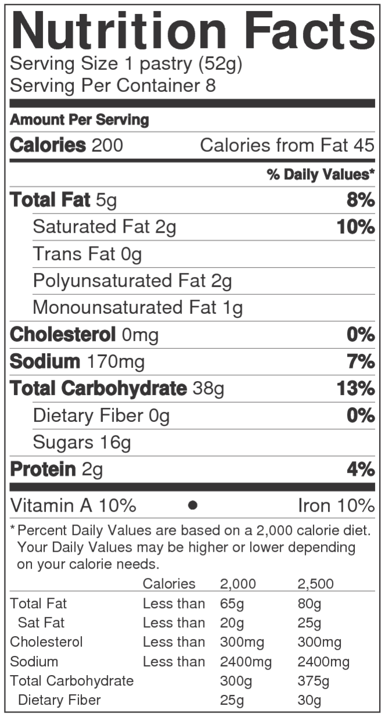

Citric Acid for Freshness), Sugar, Cracker Meal, Contains Two Percent or Less of Wheat Starch, Salt, Dried Strawberries, Dried Apples, Dried Pears, Cornstarch, Leavening (Baking Soda, Sodium
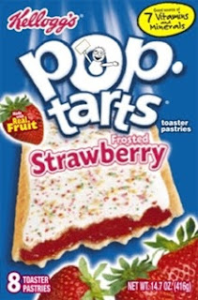

Acid Pyrophosphate, Monocalcium Phosphate), Citric Acid, Milled Corn, Modified Wheat Starch, Gelatin, Caramel Color, Partially Hydrogenated Soybean and/or Cottonseed Oil (Less than 0.5 g Trans Fat per Serving), Modified Corn Starch, Xanthan Gum, Soy Lecithin, Col- or Added, Niacinamide, Reduced Iron, Red No. 40, Vitamin A Palmitate, Yellow No. 6, Pyridoxine Hydrochloride (Vitamin B6), Riboflavin (Vitamin B2), Thiamin Hydrochloride (Vitamin B1), Folic Acid, Turmeric Color, Blue No. 1.

1. What flavor is this Pop Tart?

2. Underline the strawberries in the ingredient list.

3. Circle the ingredients used to color the strawberry filling.
4. Do you think “Made with real fruit” that appears on the front of the package is a credible description?

5. How many grams of sugar are there per serving/Pop Tart?

6. How many teaspoons of sugar are in a Pop Tart?
(HINT: there are 4 grams of sugar per teaspoon)

7. What nutrition grade should this product get? (examples: A, B+, C-) Write the grade in the
Nutrition Grade circle above.
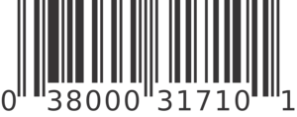

Scan this barcode with the
Fooducate app to learn more

www.fooducate.com

NAME: CLASS: DATE:

Let’s Get Fooducated!

Product: Ingredient List: Nutrition Facts:

SUGAR, UNBLEACHED ENRICHED FLOUR (WHEAT FLOUR, NIACIN, REDUCED IRON, THIAMINE MONONITRATE {VITAMIN B1}, RIBOFLAVIN {VITAMIN B2},
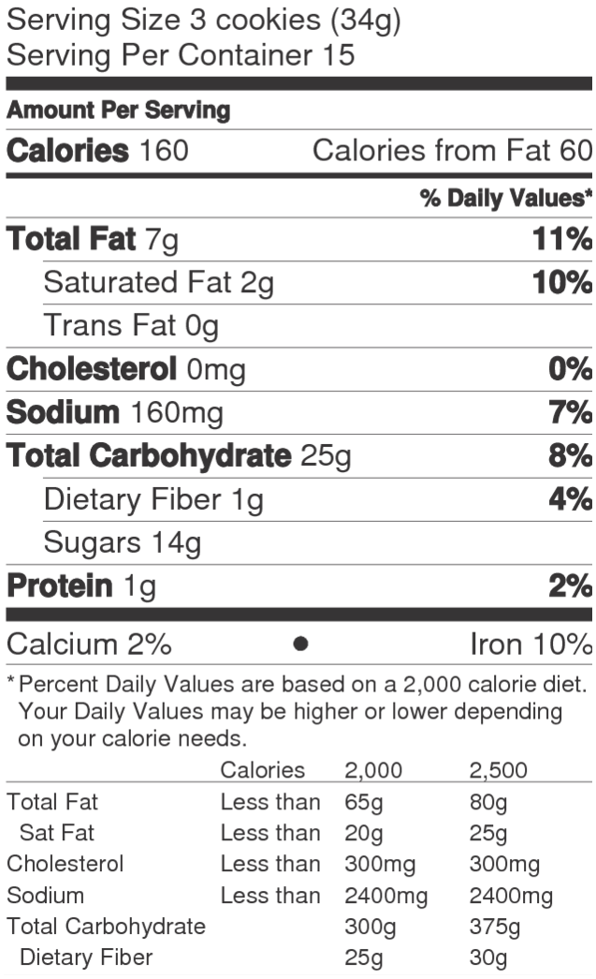

FOLIC ACID), HIGH OLEIC CANOLA AND/OR PALM OIL, COCOA (PROCESSED WITH ALKALI), HIGH FRUCTOSE CORN SYRUP, CORNSTARCH, LEAVENING (BAKING SODA
AND/OR CALCIUM PHOSPHATE), SALT, SOY LECITHIN, VANILLIN-
-AN ARTIFICIAL FLAVOR, CHOCOLATE. CONTAINS: WHEAT, SOY.

1. How many cookies are in a serving?

2. How many servings are in a package?

3. How many cookies are in a package?

4. How many cookies do you have for a snack?

5. What’s the first ingredient listed in the ingredient list?

6. How many grams of sugar per serving?

7. How many teaspoons of sugar per serving? (HINT: there are 4 grams of sugar per teaspoon)

8. Approximately how many teaspoons of sugar are in each cookie?

9. What nutrition grade should this product get? (examples: A, B+, C-) Write the grade in the Nutrition
Grade circle above.
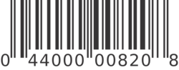

Scan this barcode with the

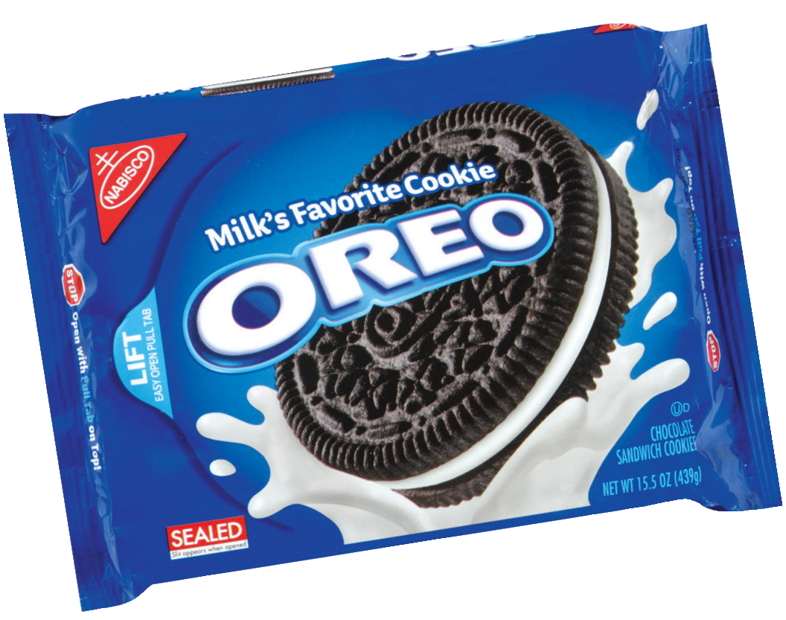

Fooducate app to learn more

www.fooducate.com

